How to Build Angular Application
  - RS806 – Software Modules for Ticketing System
● 13 Mar 2026

Author: USER Experience Researchers Pte. Ltd.
Table of Contents
1 Document Control 3
2 Introduction 4
3 Application 5
3.1 Pre-requisite to use Locally Offline 5
3.2 Build Source Code 5

Document Control
Document Title: RS806_How to build Angular Application.docx
Release:
Version | Date Release | Author | Change Details
1.0 | 15 May 2025 | Manan Mahasyah | Initial draft
- | 13 Mar 2026 | Manan Mahasyah | Update how to build the angular and include Pre-requisite

Introduction
This document to describe how to setup, build and run the MDCS application.

Application

Pre-requisite to use Locally Offline
- OS: Windows
- Install
  - NodeJS
  - NPM
  - Angular Library
    - With node.js and npm installed, the next step is to install the Angular CLI which provides tooling for effective Angular development. From a Terminal window run the following command: npm install -g @angular/cli.

- Folders and Files Important to have
  - node_modules (Folder)
  - package-lock.json (File)

Build Source Code
Retrieve the latest code from the following GitLab repository:
Repository URL: https://gitlab.com/rs806/mdcs-group/lta-btds-gui\
Important: Ensure that the node_modules folder and package-lock.json file are copied into the Angular project directory, as shown in the screenshot below.
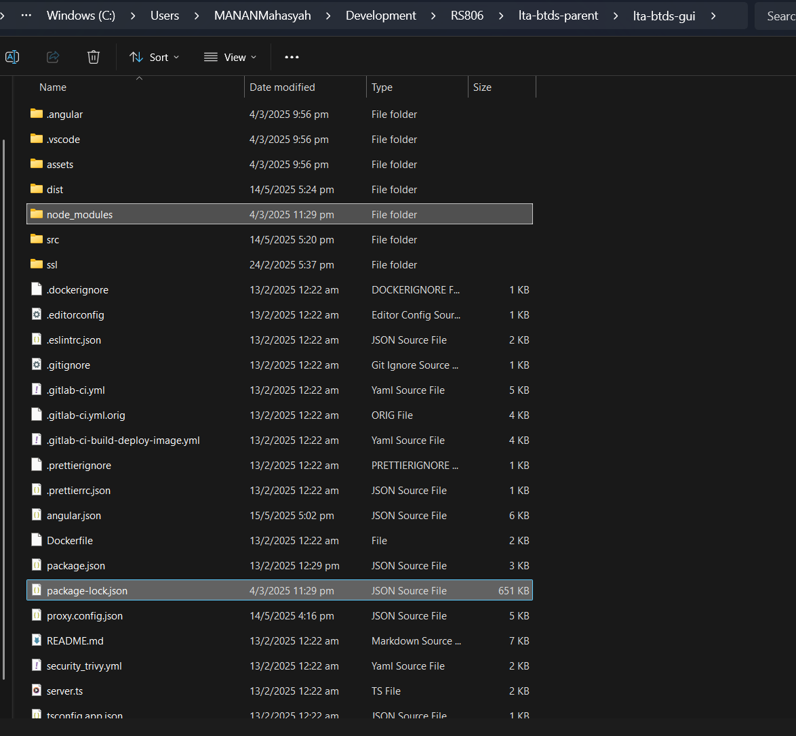
Pre-requisite before run build:
npm install -–legacy-peer-deps
Run Command:
To build the project, run the following command:
C:\Users\MANANMahasyah\<path-to>\lta-btds-gui> npm run build:uat
After a successful build, the output files will be located in the dist folder. Refer to the screenshot below for reference.